# Smart Mobile P5 Proftaak (SMPT32)

General Guidelines



Semester: 3

Module: SMPT3

Author: Michael Schifferling

Date: 7/11/12

Version 1.0

# Introduction

In this course (SMPT32) you’re going to work with a multidisciplinary group of fellow students, to create an app for Apple’s iOS platform.

In the previous period you’ve worked on a concept for the course smco31. The initial subjects for the concepts were gathered by a number of external clients/partners:

Atos, Gemoro, Sogeti and SchoolLab (iFontys)

Now it’s time to bring the concept to life.

It might be possible that not all the ideas are realistic, or maybe some features are missing, but one thing is certain: The concept is not done…Yet.

To maximize the result in the limited set of time available, a number of deliverables have been defined:

* Group rules and values
* Finalized concept
* Feature list
* Task list (to be adjusted every week)
* Paper prototype
* Intermediate demo
* Promotion material demo
* Final result: Demo + promotion video + promotion poster + product
* Reflection + portfolio

Every week the progress shall be presented to and discussed with the tutor during a project meeting

Further along this document you’ll find details regarding the project meeting and deliverables.

Good luck and have fun.

Inhoud

Introduction 3

Project meeting 5

Regarding documentation 6

Teamwork 6

Group rules and values 7

Finalized concept 7

Feature list 7

Task list 8

Paper prototype 8

Intermediate Demo 10

Promotion Material Demo 10

Final Result 11

Reflection + portfolio 11

Deadlines 12

Grading 12

# Project meeting

There shall be a weekly progress meeting with the tutor, where the progress of the project shall be discussed and demonstrated.

Since there is only a set amount of time, it is very important that an agenda is sent in advance. Besides the agenda the minutes of the meeting should also be kept. The minutes of the last meeting are to be sent along with the agenda. In the minutes it’s important to note who is responsible for incidental tasks

To streamline the documentation process, each group shall appoint a group leader. He or she is responsible for the direct contact with the tutor and must ascertain that group members adhere to their tasks, not excluding his/her own.

The weekly meeting is not scheduled so it’s up to the project group to make an appointment with the tutor. It is the responsibility of group to arrange a suitable location for the meeting.

Presence is mandatory, both halves.

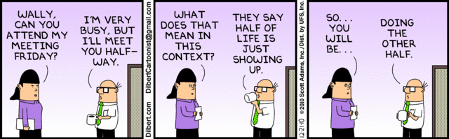

# Regarding documentation

All documentation for this course have one thing in common: It has to be ‘To the point’.

The quality of the documentation does not depend on the number of pages. Documentation has no desire to annoy you, nor be a time waster. Furthermore it doesn’t like to be anthropomorphized.



This doesn’t mean that it’s not important, or that little time and effort should be spent on it. A good presentation of the documents is very important. A well-constructed document that has readability written over it will be better graded than a hastily copy-pasted piece of text.

Take note that the documentation is ‘binding’. When you promise something in the feature list, you’re kept to that promise!

# Teamwork

So, at the end of the ‘proftaak’ you end up with a nice product. Not everything is perfect but things are working ok. Everyone in the project team worked realy hard to get the end result. At the end of the ride, everyone hands in their work, and that’s it.

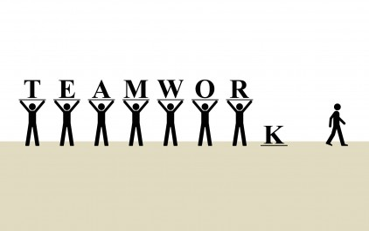

What if, instead of wasting 7 hours on finding out how to implement something, you would have just sat down with your fellow project member and helped each other. Maybe he/she could have explained the concept to you in 10 minutes, so you only need 4 hours instead. In return you could give valuable tips on how to splice an image so working with large files isn’t that hard. This is called ‘teamwork’. And if you can demonstrate this in your reflection document, you might earn a higher grade for doing so.

# Group rules and values

In this document you have to indicate what is expected from all group members, and what shall not be tolerated.

Please try to be concise and specific, so no such rules as: ‘Everyone will do their best’

What are the consequences if one arrives late? Will he/she be let off with buying cookies the first time? What about the next time? How many warnings can someone be given before action is taken? How do you determine that the quality of work is ok? Is this a democratic process?

**Deadline**: Week 1

# Finalized concept

It’s been a few weeks since you’ve looked at the final concept, so now is a good time to take a fresh look. Feel free to make adjustment where you feel that the concept is not strong overall or where features are highly improbable to be finished within the limits of time and resources available to you.

As you present your final concept to the customer some issues might arise. For example the customer would really like to see feature A, or might rather not see feature D. Use his/her input to finalize the concept.

**Deadline**: Week 2

# Feature list

The feature list is an overview of all the functionality that your app is going to offer.

It is important that you refrain from saying HOW you are going to create things, but instead indicate WHAT the app can do.

Look at it as if it’s a bullet list at the back of the product, or for example the product description on Steam (especially the key features) (<http://store.steampowered.com/app/205100/>):

 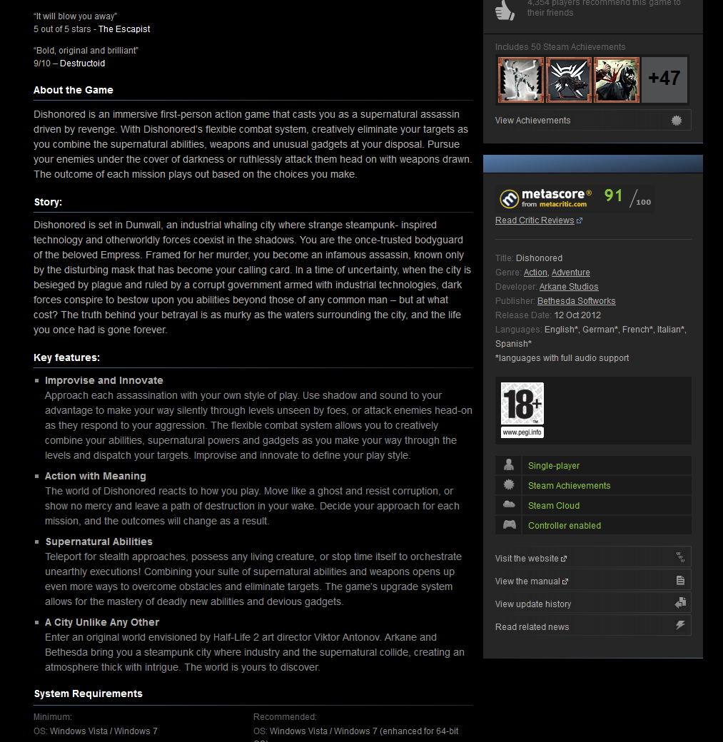

Presentation is also very important. Dumping a list is not really interesting,

**Warning**: This document is ‘binding’ and must be constructed with approval of the customer/tutor.

One more thing: All this should fit on ONE page!

**Deadline**: Week 2

# Task list

In order to give everyone the opportunity to do their work at their best, it is important to make a weekly list with tasks. When updating the task list you can use any tool or method that works for you, but try to keep the following in mind.

* A task should be clearly defined and as small as possible. Instead of saying : ‘Create database’ try to split it up in even smaller tasks: ‘Install database’, ‘create user tables’, ‘construct queries for table X’ etc.
* Before assigning a task, first discuss the global item with the whole project team. Everyone should be aware of what the task entails. For example the feature list can be created as a group session on a whiteboard, but creating the final document can be a task for one or two members.
* Try to assign multiple people to one task. It may sound like a paradox, but 1 + 1 > 2 in certain cases. Furthermore, when one of the team members is unable to attend, all hope or knowledge is not lost.
* Use the task list to keep track of work estimations. A task should typically not take more than a few hours. If a task keeps recurring, something might be amiss.

Deadline: Update before weekly project meeting

# Paper prototype

When you’ve worked on and thought about the product for a stretched period of time, it gets hard to take a good clean independent look at the result.

To aid you in making a great user interaction experience you should create a paper prototype and present this to the customer. Even better, let the customer work with the paper prototype.

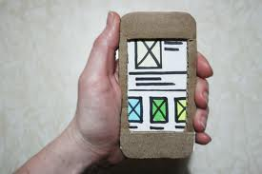

It’s important to record this session, and evaluate afterwards what you notice. For example:  
you want the customer to press the top right button to do X, but in the playback you notice that instead of pushing the button, he often tries to swipe. This might indicate that your chosen solution is not as natural or logical as you’ve thought.

Products: paper prototype on video with customer. Document with results (1 page)

**Deadline**: Week 3

# Intermediate Demo

Most products consists of multiple parts. A common mistake is waiting with connecting all the parts. If you do this at the last possible moment there is good chance that this integration will fail, or that you’ll end up with a Frankensteinesque creation.

To prevent this from happening, an intermediate demo will be given to the tutor. You should be able to show the app running on the devices, with the entire flow working. So all screens should be navigable and interaction should be fairly done.

This is not the end product, so instead of working with dynamic data ( loaded from a webservice) you can use static data (hardcoded). The same goes for the presentation. Not everything has to be complete, but enough should be done to get a good impression of the end result.

At the end of the demo, present a list with the state of the products (What features are done, how far along are the not finished items etc.)

Products: Demo and document with feature status.

**Warning**: If you get a low grade for the demo, chances are high you will not pass this course.

**Deadline**: Week 5

# Promotion Material Demo

As can be read in the paragraph above, some things should not be done at the last minute.

In the same fashion, the promotion material should not be seen as an afterthought.

You should be able to demonstrate what promotional material you are going to have at the end. Maybe a script or storyboard for the promotion video, and a quick sneak peek of the promotion poster.

Don’t feel limited by the word ‘poster’. If you have any other good and interesting products to help you promote your product, go right ahead.

Products: Showcase of promotion video, showcase of promotion poster.

**Deadline**: Week 6

# Final Result

At the end your app should be proudly demonstrated to the customer, the tutor and your fellow classmates. Exact details might vary per class, but will be given later.

The demonstration should give a good impression of general usage.

Equally important is the promotional material for your app. Try to impress the audience, and yourself.

Part of the final result is a compilation of the app sources.

This includes, but is not limited to:

* App source code
* App resources (images,videos etc)
* Webservice sourcecode (if applicable)
* Webservice database (if applicable)
* Short manual describing how to get a working app using these items

This can be given to the tutor on DVD, USB, SVN etc. If you prefer another digital method of transferring, please arrange this with the tutor.

Products: Demo, promotion video, promotion poster, final product.

**Deadline**: Week 9

# Reflection + portfolio

Grading of the ‘proftaak’ is generally done in a group based way. This time we will do things a bit different.

Try to imagine the following: Everyone starts out with a 5. Yes that’s right a 5, which is not enough to pass this course.

With the reflection and portfolio document you will have to convince the teachers that you’ve earned a better grade. Convince them with arguments. Show what you’ve (helped) creating (SVN commits, screenshots, links to documentation etc.). As discussed in the paragraph ‘Teamwork’ you can also show how you’ve contributed to the teamwork process.

Another important aspect of this document is the reflection part. How did you do things? How did things work out? What would you do different next time? What went well?

One final subject of the document should be a brief grading of yourself and your project members.

Don’t just give a grade, but also add some feedback (tops, tips)

This document shouldn’t be a book, but do give it a fair amount of attention.

**Deadline**: Week 9

# Deadlines

Deliverable deadlines are indicated in the paragraphs above.

When a deadline is passed, the grading for that part will be adjusted accordingly

# Grading

Not all deliverables have a measurable impact on your grading, but all products HAVE to be completed to receive a grade.

It’s hard to give the exact numbers per product, so what follows is an approximation.

|  |  |
| --- | --- |
| **Deliverable** | **Factor** |
| Concept | X % |
| Feature list | X % |
| Task list | X % |
| Intermediate Demo | Y % |
| Weekly agenda/minutes | 0.5 X % |
| Final demo + promotion material + product | Z % |
| Reflection/portfolio | 2 X % |

In the table above X is considerably less then Y, and Z is most certainly more than Y.